**User Manual**

Table of Contents

About 4

Helpful Links 4

Setup 4

Download 4

Installation 4

How To Use 5

Starting the program 5

Creating an account 6

Logging in to your account 7

Viewing user profile 8

Accessing the lessons 8

Accessing the exercises 9

Unlocking next lessons 10

Answering practical exercises 11

Unlocking Next Modules 12

Answering Exams 12

Viewing grades 14

Accessing Challenges 14

Answering Challenges 15

Logging out 16

Features 16

Change the theme color 16

Change the display picture 17

Viewing exam results 17

Viewing practical exam results 18

Possible Errors 18

When code is messed up 18

When hint is not working 18

When you cannot pass the practical exercises 18

Table of Figures

Figure 1: XAMPP Start Apache 5

Figure 2: Startup Page 6

Figure 3: Creating New Profile: 6

Figure 4: SignUp Page 7

Figure 5: LogIn Page 7

Figure 6: Home Page 8

Figure 7: User Profile 8

Figure 8: Modules Page 9

Figure 9: TextLessons Page 9

Figure 10: Accessing the Exercises 10

Figure 11: Practical Exercise Page 10

Figure 12: Incorrect Answer in Practical Exercise 11

Figure 13: Correct Answer in Practical Exercise 12

Figure 14: Exam Page 13

Figure 15: Practical Exam 13

Figure 16: Grades Page 14

Figure 17: Challenges Page 15

Figure 18: Practical Challenge 16

Figure 19: Theme Settings Page 17

Figure 20: Exam Results Page 17

Figure 21: Result of Practical Exam 18

# About

## Helpful Links

* Source code - <https://github.com/robertoguazon/Thesis-ITS>
* Releases (downloadable files) - <https://github.com/robertoguazon/Thesis-ITS/releases>
* Wiki about the program - <https://github.com/robertoguazon/Thesis-ITS/wiki>

# Setup

## Download

The program requires the download of the following:

* The program – either build the source code from the release page, or download the (jar or exe) zip file from the latest release
  + <https://github.com/robertoguazon/Thesis-ITS/releases>
* Emotion detection - a third party software
  + <https://github.com/mjkaufer/Emoodji>
* XAMPP – is an open source web server. This will be used to run the emotion detection.
  + <https://www.apachefriends.org/index.html>

## Installation

1. Install the XAMPP first
2. Then locate the XAMPP folder -> open htdocs -> inside htdocs place the emotion-detection folder
3. Open the emotion-detection folder and open the Generate.php file with any text editor.
4. Find this line: *$file = 'C:\\Users\\username\\Desktop\\emotion.txt';* then replace [username] with your username. Save the changes. If this does not work then change the whole path to point directly to your desktop with emotion.txt at the end.
5. If you are using the exe program jump to step number 6 else if you are using the jar program then open the Thesis-ITS folder then locate the resources folder. Jump to step number 7.
6. Open the Thesis-ITS folder then go to app folder and then resources folder. Read step number 7.
7. Open the fer folder and open the FacialExpressionRecognitionPath file rename the line: *C:\Users\username\Desktop\emotion.txt* then replace [username] with your username. Save the changes. If this does not work then change the whole path to point directly to your desktop with emotion.txt at the end.
8. Open the XAMPP and start the apache. See the picture below.

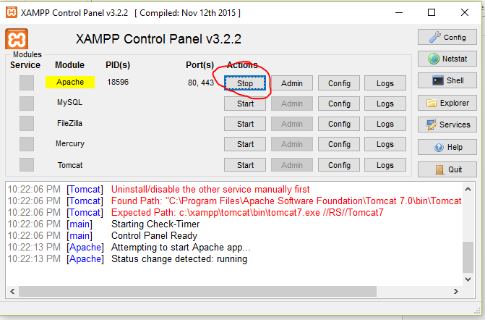

Figure 1: XAMPP Start Apache

1. The program is now ready to run.

# How To Use

## Starting the program

Click the **Thesis-ITS.jar** if you are using the jar program otherwise the **Thesis-ITS.exe**. This will open up the program.

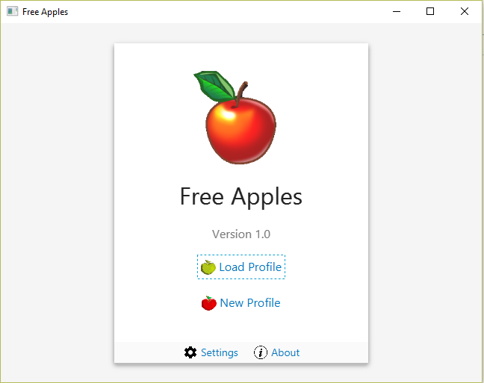

Figure 2: Startup Page

## Creating an account

On startup click the **New Profile** button to direct you to the Sign up page.

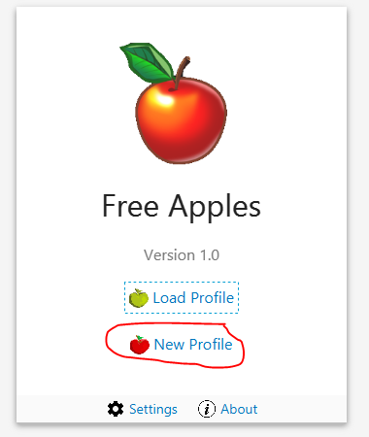

Figure 3: Creating New Profile:

Fill up all the necessary fields. You can also enter a display picture by clicking the **Browse…** button and locating the image file. Then click **Create Profile** to create your account.

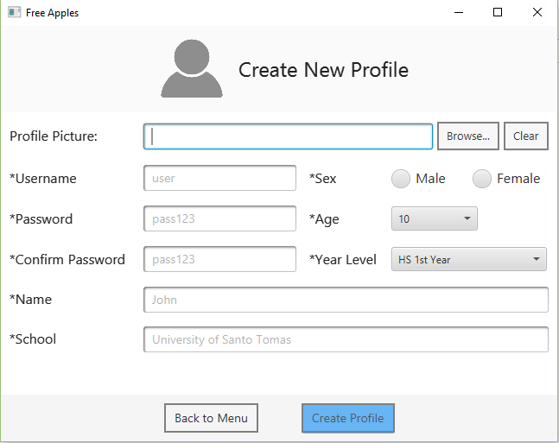

Figure 4: SignUp Page

## Logging in to your account

Click the **Load Profile** button on the startup page. This will direct you to the sign in page. Fill in the fields with the correct username and password. Click the **Login** button to login. This will direct you to the home page.

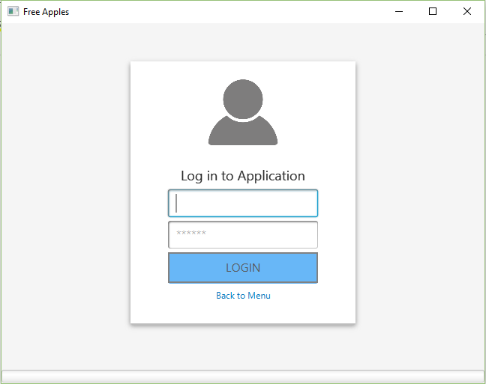

Figure 5: LogIn Page

The home page

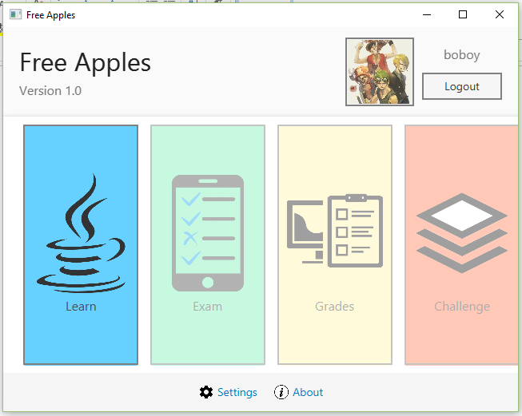

Figure 6: Home Page

## Viewing user profile

Click the **picture** near the **Logout** button to view user profile

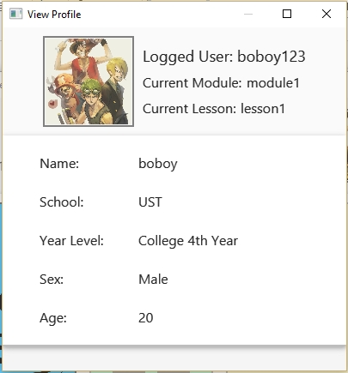

Figure 7: User Profile

## Accessing the lessons

To access the lessons, all you need to do is click the **Learn** button. Then a list of modules will popup. Pick the available ones. This will direct you to the lessons. You can see in *Figure 8* and *Figure 9* the modules and lessons pages. The first module is unlocked while the others are still locked. You will need to pass the exams first in order to unlock the following modules. The system follows a ladder approach (step by step).

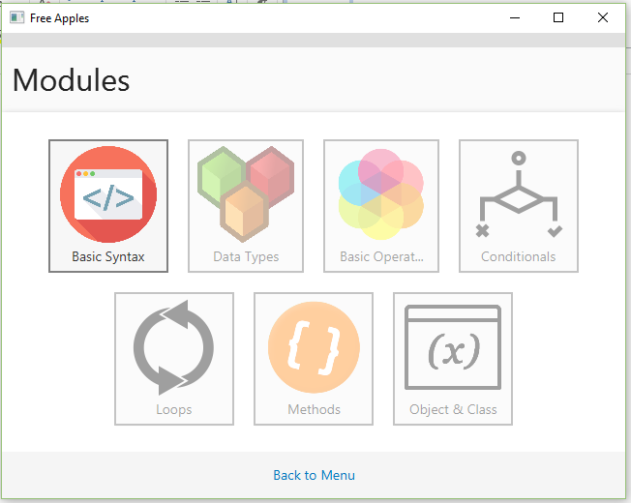

Figure 8: Modules Page

The lessons are written in html, css and javascript. There are interactive buttons need to be clicked to show the texts within the text lessons as shown in *Figure 9*.

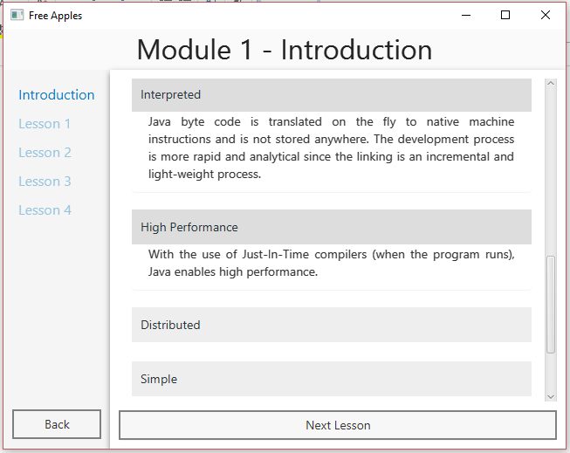

Figure 9: TextLessons Page

## Accessing the exercises

Some lessons have exercises some have none. To open the exercise page just click the **Exercise** button if they have it if none then you will see either “Next Lesson” or “Take Exam” written in the button. After clicking the **Exercise** button the exercise page will pop up.

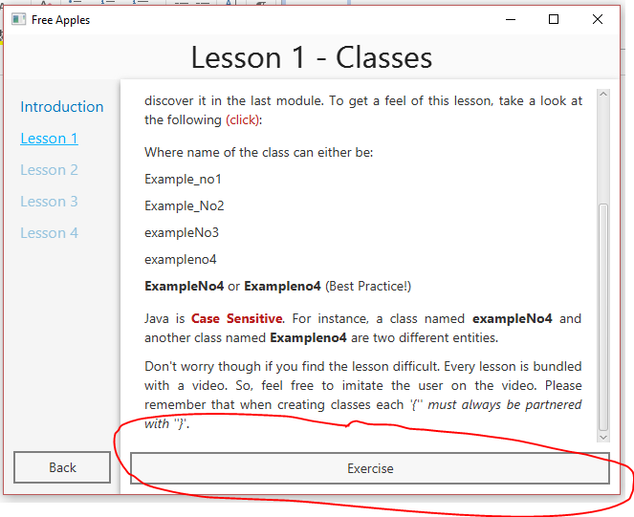

Figure 10: Accessing the Exercises

In the exercise page you can either watch the video first or just answer the practical exercise. The user has the option to choose.

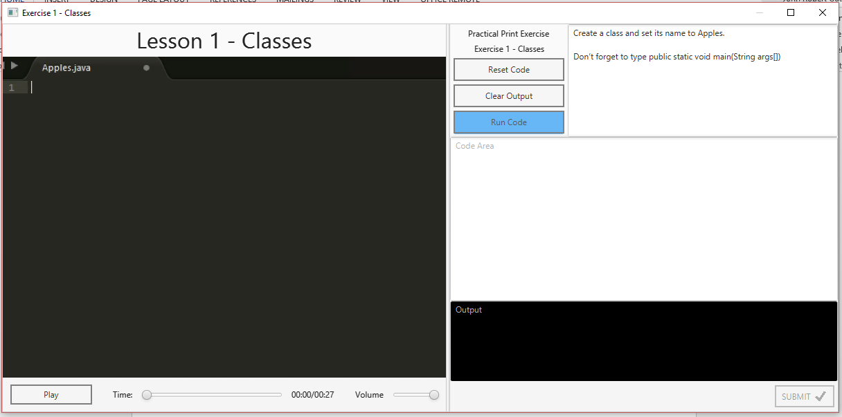

Figure 11: Practical Exercise Page

## Unlocking next lessons

If exercise does exist in the current lesson you will need to complete the **exercise** first before unlocking the next lesson. Otherwise you just need to click the **Next Lesson** button.

## Answering practical exercises

There is an instruction, code, and console text areas. You will be needing to follow the instructions correctly in order to pass the exercise. You will be needing to write your code in the **Code** text area and then click run to check if it is correct. If the code is wrong then there will be a response in the **Response** box near the **Submit** button to indicate what went wrong. Also the console will output all the specific errors. You can see in *Figure 12* how the program respond when the user is wrong. And in *Figure 13* when the user is correct.

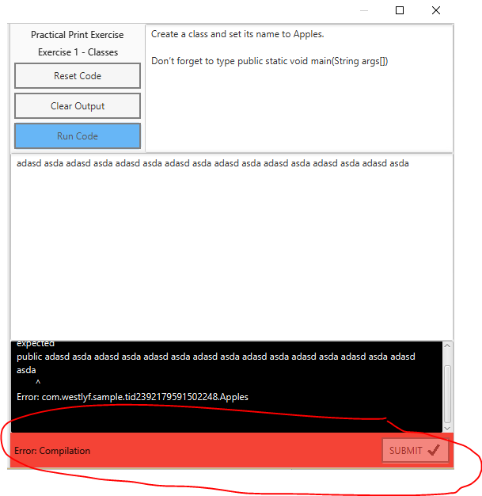

Figure 12: Incorrect Answer in Practical Exercise

When the user is correct the **Submit** button will be enabled. The **Code** text area is now disabled. It is disabled so that the user cannot edit the correct answer before saving the code to database. But, the user can answer the exercise again and change the code. The program will only disable the code text area if the answer is correct so as not to modify the code that will be saved before pressing the submit button.

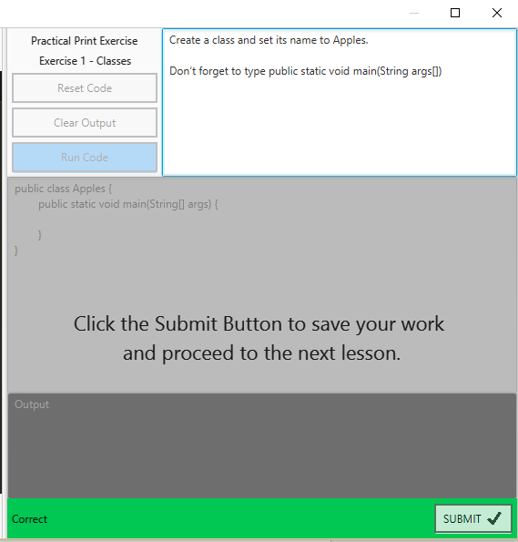

Figure 13: Correct Answer in Practical Exercise

## Unlocking Next Modules

To unlock the next module you will need to pass the exam after you have completed all the lessons in the latest module (this also means that you will need to complete all the exercises in that module). If you failed then you will need to retake the exam. Beware cause the number of retakes are computed to check whether you really pass the exam or not.

## Answering Exams

Once the **Exam** button is unlocked click it. This will open up a pop up which provides information about the exam. Click ok to direct you to the exam page. As shown in *Figure 14* there is a timer, next and previous button, an instruction text area, choices buttons, and a code button for 1 practical exam. To answer the exam just click a button from one of the choices. If the **emotion detection** program detected that you are **anxious** then the hint button will be enabled. You can press the **Hint** button to show hint. Use the left and right button to navigate through the questions. If you haven’t answered the practical exam and you pressed the **Submit Exam** button then the practical exam will pop up so that you can answer it. Also, if the timer expired then the program will auto-submit the exam and you will not be able to answer the practical exam anymore.

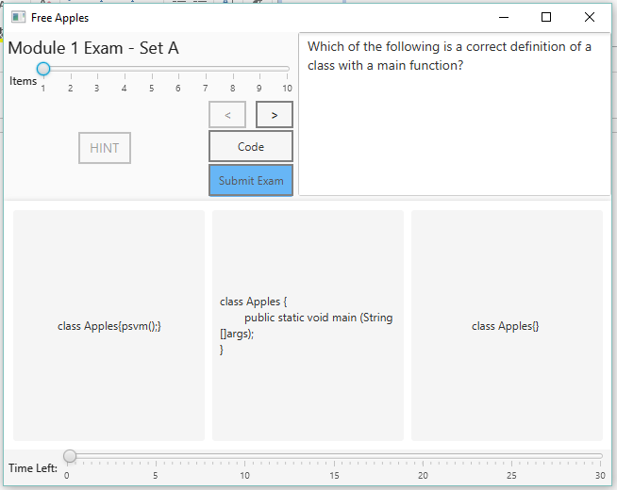

Figure 14: Exam Page

The practical exam is very much different compared to the practical exercise. There is no console and response.

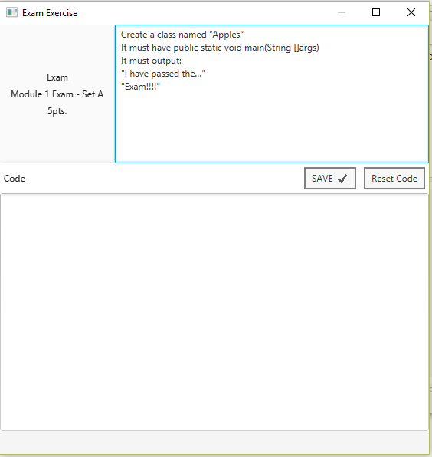

Figure 15: Practical Exam

## Viewing grades

After you’ve just received a grading mark the grades page will be available. You can view your grades by clicking the **Grades** button from the home page. In the grades page you can view your overall grade, grades per module, and info regarding the exams that you take.

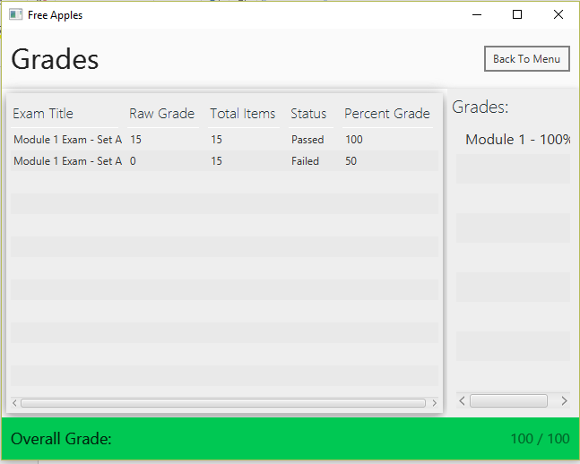

Figure 16: Grades Page

## Accessing Challenges

To access the **Challenges** page just complete all the exercises and be sure to finish all the exams. This page is just an additional page that exists for fun so that you can test your skills after you’ve known the basics. Just pick a challenge then the page for practical challenge will popup.

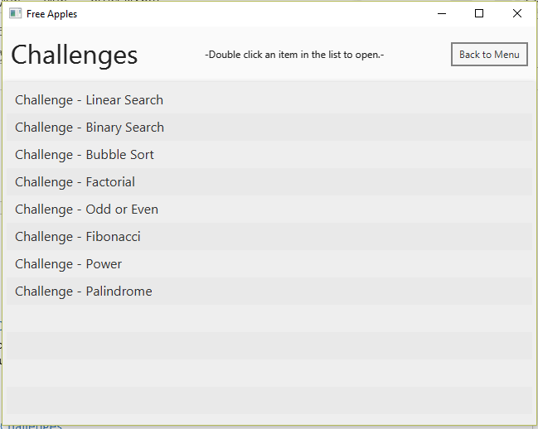

Figure 17: Challenges Page

## Answering Challenges

All the challenges are practical. They are pretty much the same with practical exercise except that in challenges you need to make a method by following the instructions. There are code, console and instruction text areas. You can write the code in the text area. Click the execute button to check if the code is acceptable or correct.

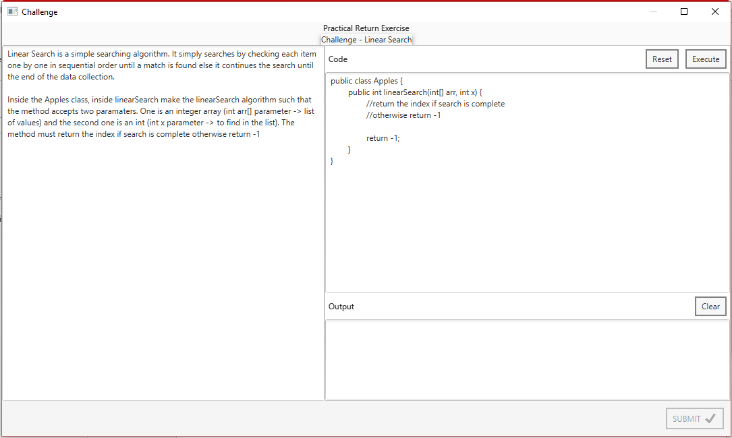

Figure 18: Practical Challenge

## Logging out

Click the **Logout** button in the home page to log out.

# Features

## Change the theme color

Click on **Settings** Button either in the startup or home page. Choose a theme then click **Apply** button to save.

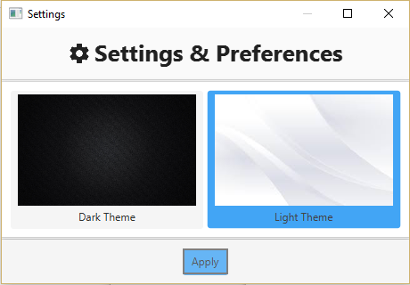

Figure 19: Theme Settings Page

## Change the display picture

Click on the **picture** on the home page near the **Logout** button to view **profile**. Then click the picture again and a new window will popup showing the displaying the picture in its original size. Click **Browse** button, choose the new image then click the **Save** button to save it.

## Viewing exam results

After you pass the exam a window with exam results will popup. This includes the information about the exams. It shows a table containing the choices, correct answers, user’s answers, questions and explanations. You can also see in the upper right corner the exam grade.

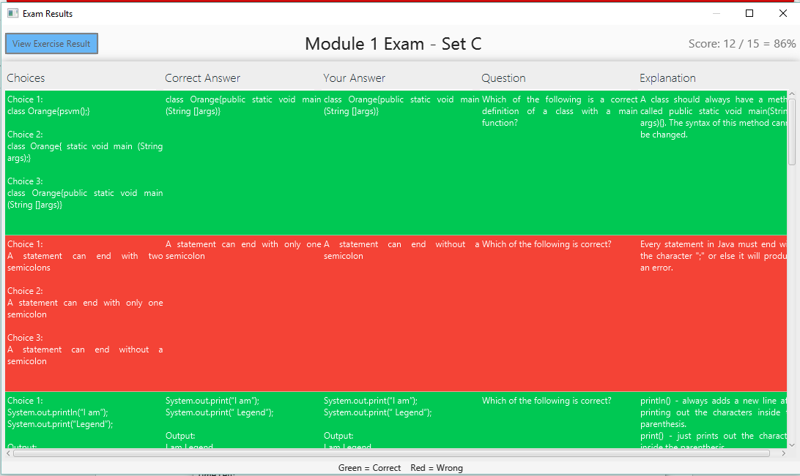

Figure 20: Exam Results Page

## Viewing practical exam results

Click the **View Exercise Results** button in the upper left corner of the exam results page. This shows the points system of the practical exercise including the output as you can see in the console in *Figure 21*.

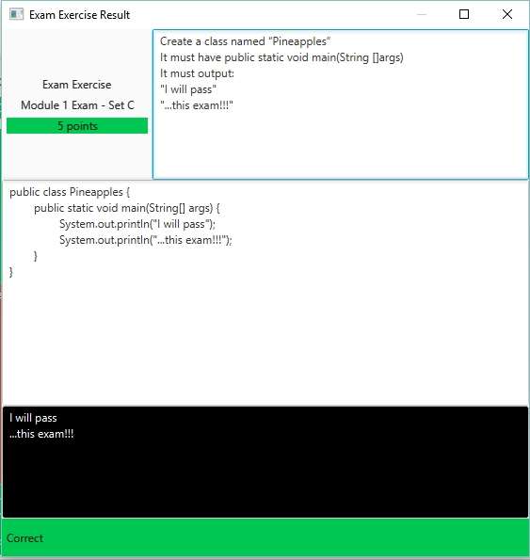

Figure 21: Result of Practical Exam

# Possible Errors

## 

## When code is messed up

Click the **Reset** button to reset code to saved data if there are any or to the given.

## When hint is not working

Try to fix the path of the emotion detection in the Generate.php and FacialExpressionRecognitionPath files.

## When you cannot pass the practical exercises

If the expected and actual outputs are the same and the response still says: “Output not match” then try to use a different approach in getting the desired output or just follow the instructions, text lessons or videos. If nothing fixed after that then this might be an error in our part when we input the exercise.